**Privacy Notice (offenders)**

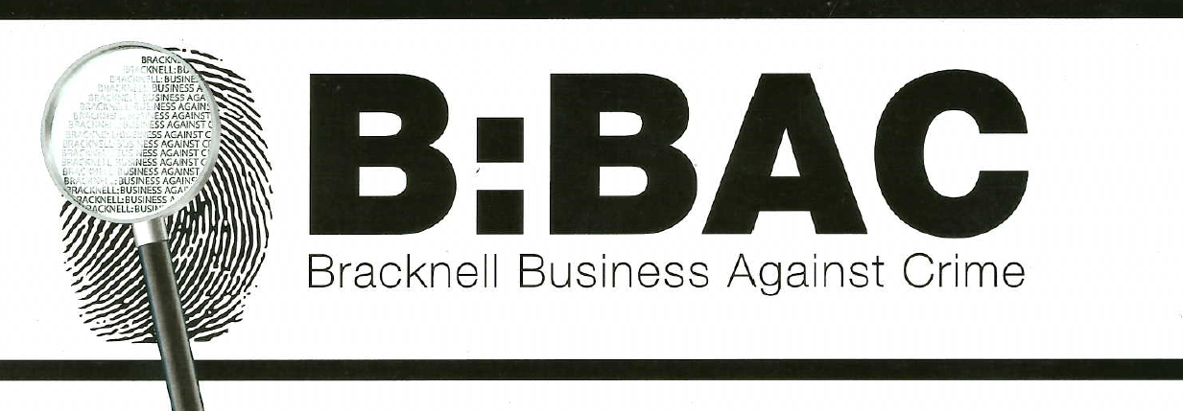

**Exclusion Scheme**

**Bracknell Business Against Crime**

**Police Station**

**Broadway**

**Bracknell**

**RG12 1AD**

Members of the B:BAC Scheme have the right to protect their property, staff and customers from crime and anti-social behaviour and to exclude from their premises anyone who is a proven threat to their property, staff or customers. The scheme processes your personal data for this purpose.

We may process your personal data by collecting, storing, retaining, collating and sharing it. We may also process your de-personalised data for analysis, historical comparisons etc.

Our Members’ “Legitimate Interests” provides the lawful basis on which we may process your personal data.

We may process only the following information about you:

* Your name and facial image and any relevant information about the nature of your activities so that Members can identify you, submit reports about you, include you in a list or gallery of excluded persons and, if appropriate, ensure our Members are aware of any threat you may represent to the personal safety of Members and their staff, customers etc.
* Your postal and email addresses, telephone number(s) and other contact details so our Scheme Co-ordinator can communicate relevant information with you from time to time.
* Your ethnicity so we can assist our Members to identify a Known Offender in order to submit a report about them, or to identify prolific or travelling offenders.
* Information and evidence about incidents in which you have been involved, so our Co-ordinator can defend our rights against any legal claims you may make against us.

We may collect your personal information from:

* Yourself
* Members of the Scheme
* Police or other public agencies.

We may circulate your personal information among:

* Members of the Scheme
* Employees and officers of the public agencies involved in the prevention and detection of crime
* Data Controllers of other organisations like us, in neighbouring areas if there is evidence that you have participated, or are likely to participate, in any threat or damage to property, staff and customers in areas outside the Scheme’s area of operation.

If you are reported by a Member for participating in any threat or damage to any Member’s property, staff or customers, your name and facial image may be shared among Members for 24 months, after which it will be withdrawn from members and irrevocably deleted from our database.

If during the 24 months when your data is circulated among Members you are reported for another such incident your name and facial image will be circulated among Members for 12 months from the date of the last incident report. **You may also be excluded from all properties (buildings and associated open land) of all Members for 12 months, and this fact will be shared with Members.**

If no further report is submitted by a Member during 24 month period, your data will be withdrawn from Members and irrevocably deleted from our database.

The exception to this is with regards to CBO Applications. If you have a successful CBO Application made against you, your data is circulated among Members for the length of the CBO, up until the expiry date. This could be indefinitely if the CBO does not have an end date.

You have the right to obtain a copy of all the personal data which we process. To do so, contact us (details above).

If you believe that any of the data we process about you is incorrect, unnecessary or disproportionate, you can require us to correct it. **You do not have the right to require us to delete correct, necessary or proportionate information.**

You also have the right to complain about us to the Information Commissioners Office at <https://ico.org.uk/concerns/handling/>